Nepal College of Information Technology
Unit Test
Fall 2011
Program : BE ELX Time : 2 hrs
Semester : Fall (V) FM : 50
Subject : Signal & Systems PM : 25

- Candidates are requested to give their answer as far as practicable in their own words.
- The figure in the margin indicates the full marks
- Attempt ALL question
1. a) Determine whether or not the system 10
y(t) = t²x(t)
i) Casual
ii) Linear
iii) Time invariant
iv) Static
v) Stable
Also define the above systems with suitable example.
b) For the given signal x(t), find the output signal y(t) if it passes through the given system 5
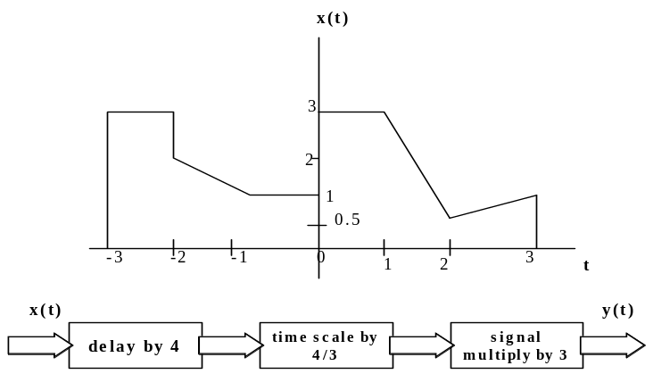
2. a) Find the exponential Fourier Series of the following waveform 7
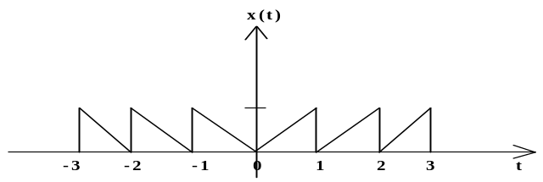
b) Define DTFS. Also determine the DTFS coefficient s of the given signal. 8
x[n] = 2+ sin (4πn/21) + cos(10πn/21)
3. a) Define Fourier Transform. Prove modulation property of continuous time Fourier Transform. 8
b) Obtain the continuous time Fourier Transform of a rectangular pulse of duration 2 seconds and having magnitude of 10 volts, starting from origin. 7
4. Write short notes on (any two): 2*2.5=5
a) Energy and Power Signal
b) Trigonometric Fourier Series and Symmetric condition
c) Transformation of independent variable

